3.4.1 The Integral Test

Motivation: Finding the exact sum of a series is, in general, difficult. This is because the formula for the partial sum of a series is usually quite complicated. Due to this, we will concentrate in the next few sections on simply determining whether or not a series converges without explicitly finding the sum. We will also discuss some ways to obtain estimates for the sum of convergent series.

One series which does not have a “nice” formula for its partial sum is: . Suppose we want to know whether this series converges or diverges.

In order to attack this question we will consider the integral: . Suppose we approximate this integral (with rectangles) by partitioning the interval into subintervals of length 1 and use left endpoints of the subintervals to establish the height of our rectangles. A picture of this is below:

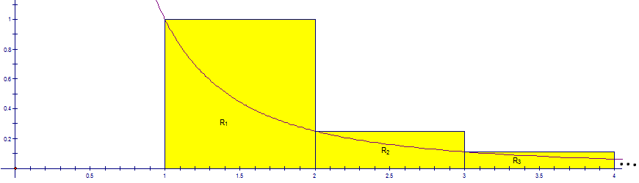

We see that the area of is 1, the area of is , and the area of is . In general, there will be an infinite number of rectangles drawn under the curve and the area of will be . A formula for the sum of the area of all the rectangles under the curve would be .
Since this approximation is clearly an overestimate it is reasonable to conclude that if is divergent, then is divergent.
We note that . Therefore, we cannot conclude that diverges.
Note: In fact in higher level mathematics it is possible to prove that .
On the other hand, suppose we approximate this integral (with rectangles) by partitioning the interval into subintervals of length 1 and use right endpoints of the subintervals to establish the height of our rectangles. A picture of this is below:

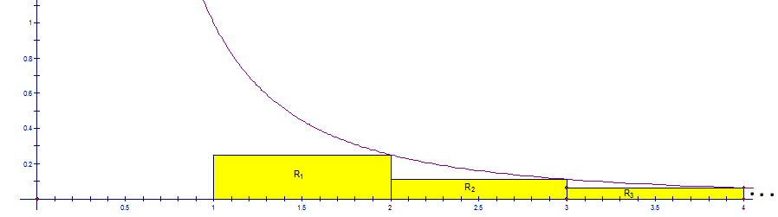
We see that the area of is , the area of is , and the area of is . In general, there will be an infinite number of rectangles drawn under the curve and the area of will be . A formula for the sum of the area of all the rectangles under the curve would be .

Clearly this approximation is an underestimate of . So, if is convergent, will bound the partial sums of from above, and we will have that is convergent since the sequence of its partial sums is increasing (by the monotonic sequence theorem).

Note: The above motivating example leads to the main theorem of the section.

Theorem (The Integral Test): Suppose f is a continuous, positive, decreasing function on and let . Then,
- If is convergent, then is convergent.
- If is divergent, then is divergent.

Proof: See the textbook.

Note: More generally, the integral test will work regardless of where the index begins. So if the index begins at “a” and we have a decreasing positive function on , we can apply the integral test.
Example 1: Determine (with justification) whether the series converges or diverges.

First we note that the function is continuous, positive, and decreasing on . Now, we calculate that:
Since is convergent, we know that is convergent by the integral test.
$$∎$$

Example 2: What is the simplest way to determine whether the series converges or diverges?

Here it is easy to answer the question by looking at the divergence test. We let and note that. Therefore and by the divergence test the series diverges.
$$∎$$

Alternatively, we could have shown the series diverges using the integral test (details below).
Let . Note thatcan be simplified as follows:.
From here we can see that is a continuous, positive, decreasing function on , so the integral test applies.
Therefore, by the integral test, since diverges the series diverges.
$$∎$$

